TikTok
More than two-thirds of TikTok users are between 18 and 34 years old.
TikTok's user demographic skews slightly male, accounting for 54.3% of its user base.
Males outnumber females in all but one age group (the 55+).
The quantity of TikTok users diminishes as age increases within each age bracket.

Hegarty Lighting Users by Gender

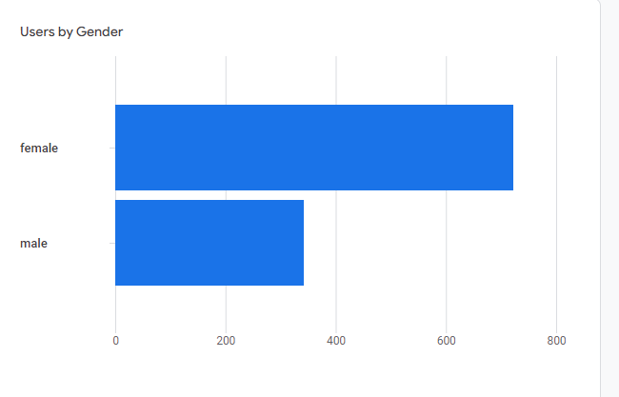
Hegarty Lighting Users by Age


